

**CS-114 - Fundamental of Programing**

**Lab Manual # 8**

**Home Task**

Submitted To: Engr Muhammad Affan

Submitted By: Shahzaib Murtaza (466034)

Section: B

**1: Take an array and find the most repeated element in that array.**

#include<iostream>

using namespace std;

int main()

{

int arr[5] = {11, 17, 33, 10, 11};

int most_repeated_number = arr[0];

int max = 1;

for(int i = 0; i <= 4; i++)

{

int t = arr[i];

int count = 1;

for(int j = i + 1; j <= 4; j++)

{

if(arr[j] == t)

{

count++;

}

}

if(count > max)

{

max = count;

most_repeated_number = t;

}

}

cout << most_repeated_number << " is the most repeated number with " << max << " " << "repetitions" << endl ;

return 0;

}

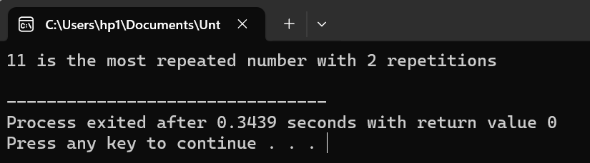

**2: Let’s say an array is a[8] = {13, 15, 17, 9, 99, 77, 65, 43}. Find largest and smallest element.**

#include <iostream>

using namespace std;

int main() {

int a[8] = {18, 5, 57, 69, 39, 71, 65, 53};

int highest = a[0];

int lowest = a[0];

for (int i = 1; i < 8; ++i) {

if (a[i] > highest) {

highest = a[i];

}

if (a[i] < lowest) {

lowest = a[i];

}

}

cout << "Maximum value: " << highest << endl;

cout << "Minimum value: " << lowest << endl;

return 0;

}

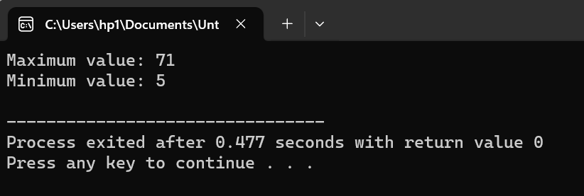

**3: Develop a program that takes 5 array elements from user. Swap position [2] element with position [4] element. (Hint: Use the same method of swapping values we used for variables using a third variable temp).**

#include <iostream>

using namespace std;

int main() {

int arr[5];

cout << "Enter Numbers:" << endl;

for (int a = 0; a < 5; ++a) {

cout << "Number " << a + 1 << ": ";

cin >> arr[a];

}

cout << "Before:" << endl;

for (int a = 0; a < 5; ++a) {

cout << arr[a] << "\t";

}

cout << endl;

int t = arr[2];

arr[2] = arr[4];

arr[4] = t;

cout << "After:" << endl;

for (int a = 0; a < 5; ++a) {

cout << arr[a] << "\t";

}

cout << endl;

return 0;

}

